DE–9052
11
DISTANCE EDUCATION
M.Phil (Chemistry) DEGREE EXAMINATION, MAY 2010.
RESEARCH METHODOLOGY IN CHEMICAL RESEARCH
Time : Three hours Maximum: 100 marks
PART A — (10 × 3 = 30 marks)
Answer ALL the questions.
- State and explain the term database.
- How will you create an e-mail id?
- What are arrays?
- What are constructors?
- Define the term sublimation.
- Explain the significance of R_{f} value in chromatography.
- Write any three hazardous chemicals.
- What are synthons? Give examples.
- What is Annelation reaction?
- What is ‘‘student t test’’? Explain its significance.
PART B — (5 × 6 = 30 marks)
Answer ALL questions.
- (a) Distinguish between primary source and secondary source. Give suitable examples.
Or
(b) What is meant by browsing? How will you download ‘‘polarisability’’ for your studies?
- (a) Explain file handling procedures with examples.
Or
(b) What are pointers? How will you access a variable in C language through a pointer? Illustrate with an example.
- (a) Write briefly on HPLC.
Or
(b) Explain the various methods for purification of solids.
- (a) Give an account on asymmetric synthesis.
Or
(b) Discuss the method of selective protection of functional groups with suitable examples.
- (a) Define the terms accuracy and precision with suitable examples.
Or
(b) What are errors? Explain the different types of error.
PART C — (4 × 10 = 40 marks)
Answer any FOUR questions.
- (a) What is chemical abstract? How is it useful in the literature survey of your proposed work on ‘‘High frequency electrochemical synthesis’’? (4)
(b) Explain the following terms :
(i) Patents
(ii) Encylopedia
(iii) Journals. (6)
- (a) Explain the operators in C⁺⁺ that cannot be overloaded. (4)
(b) Explain the following terms in C Programme.
(i) Constants
(ii) Variables
(iii) Inheritance. (6)
- (a) State and explain carcinogenic and toxic chemicals.
(4)
(b) Explain the principle, procedure and applications of thin layer chromatography. (6)
- Explain the principles of organic synthesis. (10)
- (a) How many significant figures are there in the following numbers :
(i) Rs. 646
(ii) 0.377 mg.
(iii) 1.49 × 10^{–3} nm
(iv) 20.2 ml. (4 × = 2)
(b) Define and illustrate the following :
(i) Correlation coefficient
(ii) Confidence limit
(iii) Standard deviation. (2 + 3 + 3)
- (a) Explain the principle, procedure and applications of gas chromatography. (8)
(b) A titration was repeated four times and the litre values are found to be 10.0, 10.1, 9.9, 10.2 ml. Calculate the mean and median. (2)
–––––––––––––––
DE–9053
12
DISTANCE EDUCATION
M.Phil. (Chemistry) DEGREE EXAMINATION, MAY 2010.
INSTRUMENTAL METHODS OF ANALYSIS
(2006 onwards)
Time : Three hours Maximum : 100 marks
PART A — (10 × 3 = 30 marks)
Answer ALL questions.
- Which of the following two compounds is expected to have the carbonyl stretching at a higher frequency. Why?
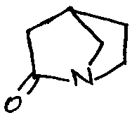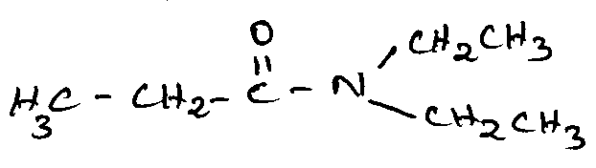
- 1,3 – Butadiene has a 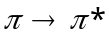 transition at 217 nm whereas 1,3 – Pentadiene has the same at 223.5 nm. How would you account for the increase in the wavelength of the absorption peak in the case of the latter?
- 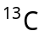 carbonyl chemical shift of acetophenene is 196 ppm, whereas that of 2, 6 –dimethyl acetophenene is 206 ppm. Explain.
- How will you distinguish between the following pairs using 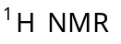?
(a) 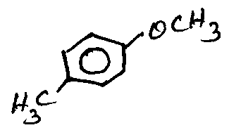 and 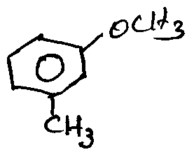
(b) 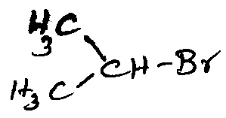 and 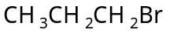. (1.5+1.5)
- What is Kramers degeneracy?
- Predict the number of ESR lines in the hyperfine spectrum of 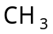 radical.
- What are the differences between ORD and CD curves?
- Give the fragmentation pattern of the following compounds.
(a) Benzyl alcohol
(b) 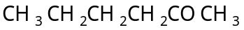. (1.5+1.5)
- Differentiate between atomic absorption and emission spectroscopies.
- What is the principle of colourimetric analysis?
PART B — (5 × 6 = 30 marks)
Answer ALL questions.
- (a) (i) Explain how infrared spectroscopy can be used to study inter and intra molecular hydrogen bonding. (4)
(ii) Using the Woodward – Fieser rules, calculate the 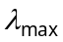 for the following compounds.
(1) 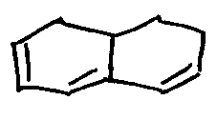
(2) 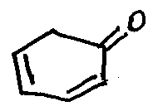 (1+1)
Or
(b) (i) The ultraviolet spectrum of bimesityl resembles that of mesitylene while that of 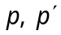- bitolyl does not resemble that of toluene. Can you suggest an explanation for this?
(ii) Addition of sodium hydroxide and phenol shifts the UV absorption from 280 nm to
293 nm. Explain. (3+3)
- (a) Describe briefly the difference in the position of absorption as noted in the case of 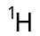 NMR spectrum of acetylene and benzene.
Or
(b) (i) Write a short note on Nuclear overhauser effect.
(ii) What are chemically equivalent but magnetically non-equivalent protons? Explain with suitable examples. (4+2)
- (a) Describe some important applications of EPR spectroscopy.
Or
(b) Discuss the applications of Mossbauer spectroscopy to iron and tin compounds.
- (a) How are the configurational and conformational problems solved using cotton effect?
Or
(b) Write an account of metastable ion.
- (a) Write an account of the two evaluation methods used in flame photometry.
Or
(b) Give a brief account of coulometric analysis.
PART C — (4 × 10 = 40 marks)
Answer any FOUR questions.
- (a) What is meant by coupled vibrations in IR? Explain with suitable examples.
(b) In the IR spectrum of the methylester of
o – chlorobenzoic acid two bands for the carbonyl stretching appear at 1685 and 1708 cm^{–1}. Rationalise this observation.
(c) Write briefly on the classification and identification of different electronic transitions observed in acetone molecule. (4+3+3)
- (a) Taking 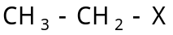 as an example explain the phenomenon of spin-spin splitting. What are the factors that affect spin-spin splitting?
(b) Describe the use of DEPT method in assigning signals. (5+5)
- Write a note on :
(a) Mossbauer emission spectroscopy.
(b) McConnel relationship. (5+5)
- Discuss the following :
(a) McLafferty rearrangement.
(b) Axial haloketone rule. (6+4)
- (a) What are the advantages and disadvantages of using DME in polarography?
(b) Discuss the principle and applications of
electrogravimetry. (5+5)
- An organic compound of the molecular
formula 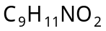 has an IR peak at 1708 cm^{–1}. Its NMR spectrum (ppm, CDCl₃, TMS, 300 MHz) has absorptions at 1.36 (triplet, 3H), 3.78 (broad peak, 2H), 4.34 (quartel, 2H), 6.81 (doublet, 1H), 7.18 (triplet, 1H), 7.34(singlet, 1H) and 7.41(doublet, 1H).
Its normal carbon NMR (ppm, CDCl₃, TMS), DEPT – 135 and DEPT – 90 spectral data are tabulated below:
Normal carbon ppm | DEPT – 135 | DEPT – 90
14 | Positive | No peak
61 | Negative | No peak
116 | Positive | Positive
119 | Positive | Positive
120 | Positive | Positive
129 | Positive | Positive
131 | No peak | No peak
147 | No peak | No peak
167 | No peak | No peak
Suggest a structure for the compound.
——————

